Snakebite Clinical Analysis
Md Ali Armaghan
2026-01-24

Section A: Data Import and Structure

Objective
Import the dataset, inspect structure, and prepare variables for analysis.
# Load required libraries
library(tidyverse)
library(psych)
library(ggplot2)
library(knitr)
# Import dataset
snake_df <- read_csv("Snake_bite_dataset.csv", show_col_types = FALSE)
# Number of observations and variables
n_obs <- nrow(snake_df)
n_vars <- ncol(snake_df)
cat("Number of observations:", n_obs, "\n")
## Number of observations: 100
cat("Number of variables:", n_vars, "\n")
## Number of variables: 27
# Structure and variable classes
str(snake_df)
## spc_tbl_ [100 × 27] (S3: spec_tbl_df/tbl_df/tbl/data.frame)
## $ id : num [1:100] 1 2 3 4 5 6 7 8 9 10 ...
## $ age : num [1:100] 58 50 26 34 50 19 45 67 32 51 ...
## $ gender : chr [1:100] "Male" "Female" "Male" "Male" ...
## $ diabetes : num [1:100] 1 0 0 1 0 0 0 1 1 0 ...
## $ hypertension : num [1:100] 0 0 0 0 1 0 0 0 1 1 ...
## $ ckd : num [1:100] 0 0 0 0 0 0 0 0 0 0 ...
## $ severity : chr [1:100] "Moderate" "Mild" "Severe" "Moderate" ...
## $ tlc : num [1:100] 14554 8634 17996 17874 12483 ...
## $ crp : num [1:100] 37.7 6.9 75.5 34.9 18.6 38.1 8.1 13.9 49.1 12.8 ...
## $ ldh : num [1:100] 509 253 949 378 487 337 243 289 977 223 ...
## $ albumin : num [1:100] 3.3 4.2 2.4 3.1 3 3.4 4.7 4.1 2.2 4 ...
## $ sbp : num [1:100] 106 114 82 100 104 95 118 124 75 120 ...
## $ dbp : num [1:100] 68 75 49 61 65 68 80 81 46 73 ...
## $ pulse : num [1:100] 94 94 92 76 93 111 78 119 103 71 ...
## $ rr : num [1:100] 22 20 21 20 19 14 25 26 23 22 ...
## $ spo2 : num [1:100] 99 95 90 97 96 97 96 95 86 99 ...
## $ hypotension : num [1:100] 0 0 1 0 0 0 0 0 1 0 ...
## $ icu_admission : num [1:100] 1 0 1 0 0 0 0 1 1 0 ...
## $ icu_stay_days : num [1:100] 5 0 4 0 0 0 0 7 5 0 ...
## $ cardio_comp : num [1:100] 1 0 1 0 1 0 0 0 1 0 ...
## $ resp_comp : num [1:100] 1 0 0 0 0 0 0 0 1 0 ...
## $ neuro_comp : num [1:100] 0 0 1 0 0 1 0 0 0 0 ...
## $ hemato_comp : num [1:100] 0 0 1 0 0 1 0 0 0 1 ...
## $ any_complication : num [1:100] 1 0 1 0 1 1 0 0 1 1 ...
## $ complication_count: num [1:100] 2 0 3 0 1 2 0 0 2 1 ...
## $ hospital_stay : num [1:100] 6 3 11 9 7 5 3 2 14 3 ...
## $ mortality : num [1:100] 0 0 0 0 0 0 0 0 0 0 ...
## - attr(*, "spec")=
## .. cols(
## .. id = col_double(),
## .. age = col_double(),
## .. gender = col_character(),
## .. diabetes = col_double(),
## .. hypertension = col_double(),
## .. ckd = col_double(),
## .. severity = col_character(),
## .. tlc = col_double(),
## .. crp = col_double(),
## .. ldh = col_double(),
## .. albumin = col_double(),
## .. sbp = col_double(),
## .. dbp = col_double(),
## .. pulse = col_double(),
## .. rr = col_double(),
## .. spo2 = col_double(),
## .. hypotension = col_double(),
## .. icu_admission = col_double(),
## .. icu_stay_days = col_double(),
## .. cardio_comp = col_double(),
## .. resp_comp = col_double(),
## .. neuro_comp = col_double(),
## .. hemato_comp = col_double(),
## .. any_complication = col_double(),
## .. complication_count = col_double(),
## .. hospital_stay = col_double(),
## .. mortality = col_double()
## .. )
## - attr(*, "problems")=<externalptr>
# Convert appropriate variables to factors
snake_df <- snake_df %>%
mutate(
gender = factor(gender),
severity = factor(severity, levels = c("Mild", "Moderate", "Severe"), ordered = TRUE),
# Comorbidities
diabetes = factor(diabetes, levels = c(0, 1), labels = c("No", "Yes")),
hypertension = factor(hypertension, levels = c(0, 1), labels = c("No", "Yes")),
ckd = factor(ckd, levels = c(0, 1), labels = c("No", "Yes")),
# Vital-derived variable
hypotension = factor(hypotension, levels = c(0, 1), labels = c("No", "Yes")),
# Create derived laboratory abnormality variables
# Note: Clinical cutoffs used are standard reference values
leukocytosis = factor(ifelse(tlc > 11000, 1, 0),
levels = c(0, 1), labels = c("No", "Yes")),
elevated_crp = factor(ifelse(crp > 10, 1, 0),
levels = c(0, 1), labels = c("No", "Yes")),
elevated_ldh = factor(ifelse(ldh > 250, 1, 0),
levels = c(0, 1), labels = c("No", "Yes")),
hypoalbuminemia = factor(ifelse(albumin < 3.5, 1, 0),
levels = c(0, 1), labels = c("No", "Yes")),
# Outcomes
icu_admission = factor(icu_admission, levels = c(0, 1), labels = c("No", "Yes")),
any_complication = factor(any_complication, levels = c(0, 1), labels = c("No", "Yes")),
mortality = factor(mortality, levels = c(0, 1), labels = c("No", "Yes"))
)
Note:
Derived laboratory abnormality variables were created using standard clinical reference ranges: leukocytosis (TLC > 11,000 cells/mm³), elevated CRP (> 10 mg/L), elevated LDH (> 250 U/L), and hypoalbuminemia (albumin < 3.5 g/dL). Gender and severity were converted to factors, with severity specified as ordered to reflect disease progression.

Section B: Descriptive Statistics

Continuous Variables
# Custom summary statistics function
summary_stats <- function(x) {
c(
Mean = mean(x, na.rm = TRUE),
SD = sd(x, na.rm = TRUE),
Median = median(x, na.rm = TRUE),
Q1 = quantile(x, 0.25, na.rm = TRUE),
Q3 = quantile(x, 0.75, na.rm = TRUE),
IQR = IQR(x, na.rm = TRUE),
Min = min(x, na.rm = TRUE),
Max = max(x, na.rm = TRUE)
)
}
# Select continuous variables as per assignment requirements
continuous_vars <- snake_df %>%
select(
# Age
age,
# Vital parameters
pulse, rr, sbp, dbp, spo2,
# Laboratory parameters
tlc, crp, ldh, albumin,
# Duration variables
hospital_stay, icu_stay_days
)
# Compute summary statistics
stats_table <- sapply(continuous_vars, summary_stats)
# Display as readable table
kable(t(stats_table), digits = 2,
caption = "Summary Statistics for Continuous Variables")
Summary Statistics for Continuous Variables
 | Mean | SD | Median | Q1.25% | Q3.75% | IQR | Min | Max
age | 45.60 | 16.69 | 44.5 | 31.00 | 59.00 | 28.00 | 18.0 | 74.0
pulse | 89.45 | 14.36 | 90.0 | 79.00 | 98.00 | 19.00 | 51.0 | 125.0
rr | 20.02 | 4.26 | 19.5 | 18.00 | 23.00 | 5.00 | 8.0 | 34.0
sbp | 102.93 | 15.57 | 103.5 | 92.00 | 117.25 | 25.25 | 73.0 | 130.0
dbp | 65.65 | 10.42 | 67.0 | 61.00 | 74.00 | 13.00 | 43.0 | 85.0
spo2 | 95.47 | 3.26 | 97.0 | 95.00 | 98.00 | 3.00 | 85.0 | 99.0
tlc | 13808.23 | 4645.57 | 12637.0 | 10089.50 | 17156.25 | 7066.75 | 6277.0 | 26644.0
crp | 29.43 | 22.12 | 25.7 | 12.88 | 38.12 | 25.25 | 3.2 | 87.1
ldh | 465.34 | 247.51 | 383.0 | 268.75 | 580.75 | 312.00 | 181.0 | 996.0
albumin | 3.31 | 0.79 | 3.2 | 2.90 | 4.00 | 1.10 | 1.8 | 4.7
hospital_stay | 7.50 | 4.14 | 6.5 | 4.00 | 9.00 | 5.00 | 2.0 | 18.0
icu_stay_days | 2.19 | 2.66 | 0.0 | 0.00 | 4.25 | 4.25 | 0.0 | 8.0

Categorical Variables
# Helper function for frequency and percentage
freq_percent <- function(x, var_name) {
tbl <- table(x, useNA = "no")
result <- tibble(
Category = names(tbl),
Frequency = as.integer(tbl),
Percentage = round(as.numeric(tbl) / sum(tbl) * 100, 1)
)
cat("\n", var_name, "\n")
print(kable(result))
}
# Create age groups
snake_df <- snake_df %>%
mutate(age_group = cut(
age,
breaks = c(18, 30, 45, 60, Inf),
labels = c("18-30", "31-45", "46-60", ">60"),
right = TRUE
))
# Age Group
freq_percent(snake_df$age_group, "Age Group")
##
## Age Group
##
##
## |Category | Frequency| Percentage|
## |:--------|---------:|----------:|
## |18-30 | 21| 21.6|
## |31-45 | 29| 29.9|
## |46-60 | 25| 25.8|
## |>60 | 22| 22.7|
# Sex
freq_percent(snake_df$gender, "Gender")
##
## Gender
##
##
## |Category | Frequency| Percentage|
## |:--------|---------:|----------:|
## |Female | 24| 24|
## |Male | 76| 76|
# Hypotension at presentation
freq_percent(snake_df$hypotension, "Hypotension at Presentation")
##
## Hypotension at Presentation
##
##
## |Category | Frequency| Percentage|
## |:--------|---------:|----------:|
## |No | 78| 78|
## |Yes | 22| 22|
# Comorbidities
freq_percent(snake_df$diabetes, "Diabetes")
##
## Diabetes
##
##
## |Category | Frequency| Percentage|
## |:--------|---------:|----------:|
## |No | 76| 76|
## |Yes | 24| 24|
freq_percent(snake_df$hypertension, "Hypertension")
##
## Hypertension
##
##
## |Category | Frequency| Percentage|
## |:--------|---------:|----------:|
## |No | 67| 67|
## |Yes | 33| 33|
freq_percent(snake_df$ckd, "Chronic Kidney Disease")
##
## Chronic Kidney Disease
##
##
## |Category | Frequency| Percentage|
## |:--------|---------:|----------:|
## |No | 96| 96|
## |Yes | 4| 4|
# Derived laboratory abnormalities
freq_percent(snake_df$leukocytosis, "Leukocytosis")
##
## Leukocytosis
##
##
## |Category | Frequency| Percentage|
## |:--------|---------:|----------:|
## |No | 33| 33|
## |Yes | 67| 67|
freq_percent(snake_df$elevated_crp, "Elevated CRP")
##
## Elevated CRP
##
##
## |Category | Frequency| Percentage|
## |:--------|---------:|----------:|
## |No | 17| 17|
## |Yes | 83| 83|
freq_percent(snake_df$elevated_ldh, "Elevated LDH")
##
## Elevated LDH
##
##
## |Category | Frequency| Percentage|
## |:--------|---------:|----------:|
## |No | 22| 22|
## |Yes | 78| 78|
freq_percent(snake_df$hypoalbuminemia, "Hypoalbuminemia")
##
## Hypoalbuminemia
##
##
## |Category | Frequency| Percentage|
## |:--------|---------:|----------:|
## |No | 35| 35|
## |Yes | 65| 65|
# ICU Admission
freq_percent(snake_df$icu_admission, "ICU Admission")
##
## ICU Admission
##
##
## |Category | Frequency| Percentage|
## |:--------|---------:|----------:|
## |No | 54| 54|
## |Yes | 46| 46|
# Overall Complications
freq_percent(snake_df$any_complication, "Any Complication")
##
## Any Complication
##
##
## |Category | Frequency| Percentage|
## |:--------|---------:|----------:|
## |No | 49| 49|
## |Yes | 51| 51|

Section C: Data Visualization

Objective
Create publication-quality plots with clear titles, axis labels, and appropriate themes.
# Boxplot for age distribution
ggplot(snake_df, aes(y = age)) +
geom_boxplot(fill = "steelblue", alpha = 0.7) +
labs(
title = "Distribution of Age Among Snakebite Patients",
y = "Age (years)"
) +
theme_minimal() +
theme(
plot.title = element_text(hjust = 0.5, face = "bold"),
axis.text.x = element_blank(),
axis.ticks.x = element_blank()
)
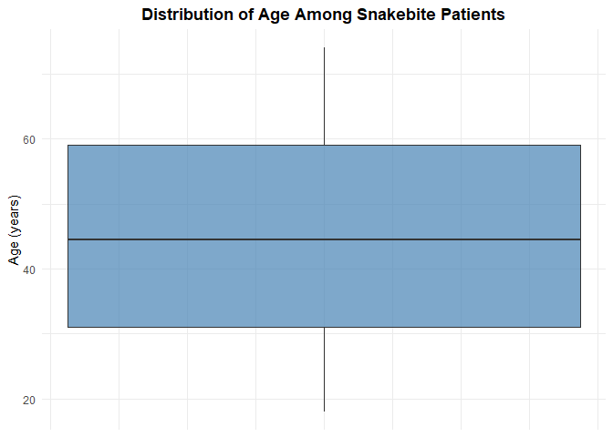
# Bar chart for sex distribution
ggplot(snake_df, aes(x = gender, fill = gender)) +
geom_bar(alpha = 0.8) +
geom_text(stat = 'count', aes(label = after_stat(count)), vjust = -0.5) +
labs(
title = "Gender Distribution of Snakebite Patients",
x = "Gender",
y = "Frequency"
) +
scale_fill_brewer(palette = "Set2") +
theme_minimal() +
theme(
plot.title = element_text(hjust = 0.5, face = "bold"),
legend.position = "none"
)
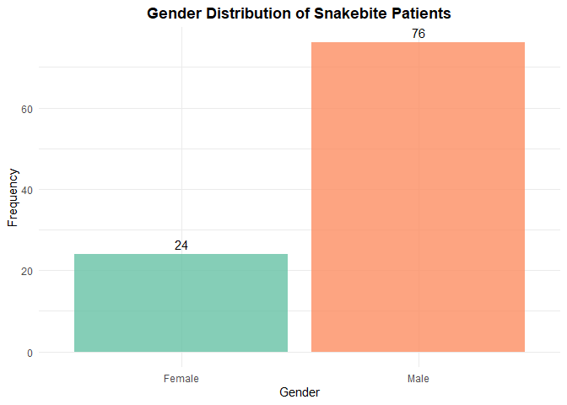
# Boxplots for laboratory parameters (CRP and LDH)
p1 <- ggplot(snake_df, aes(y = crp)) +
geom_boxplot(fill = "coral", alpha = 0.7) +
labs(
title = "Distribution of Serum CRP",
y = "CRP (mg/L)"
) +
theme_minimal() +
theme(
plot.title = element_text(hjust = 0.5, face = "bold"),
axis.text.x = element_blank(),
axis.ticks.x = element_blank()
)
p2 <- ggplot(snake_df, aes(y = ldh)) +
geom_boxplot(fill = "darkseagreen", alpha = 0.7) +
labs(
title = "Distribution of Serum LDH",
y = "LDH (U/L)"
) +
theme_minimal() +
theme(
plot.title = element_text(hjust = 0.5, face = "bold"),
axis.text.x = element_blank(),
axis.ticks.x = element_blank()
)
# Display plots side by side
library(gridExtra)
grid.arrange(p1, p2, ncol = 2)
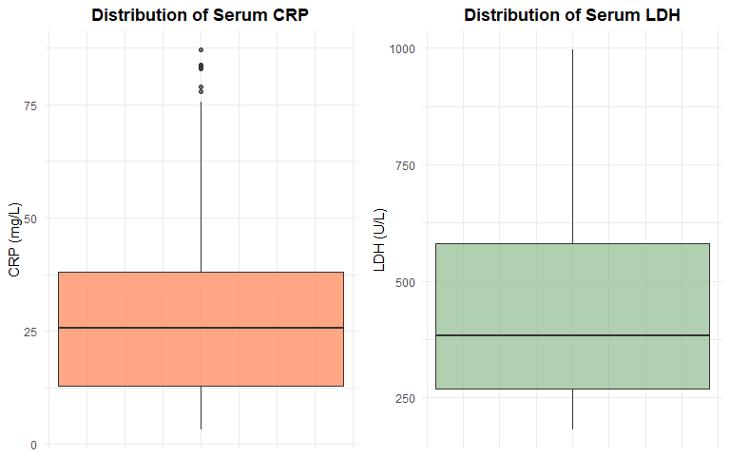
# Boxplot for hospital stay
ggplot(snake_df, aes(y = hospital_stay)) +
geom_boxplot(fill = "plum", alpha = 0.7) +
labs(
title = "Distribution of Hospital Stay Duration",
y = "Hospital Stay (days)"
) +
theme_minimal() +
theme(
plot.title = element_text(hjust = 0.5, face = "bold"),
axis.text.x = element_blank(),
axis.ticks.x = element_blank()
)
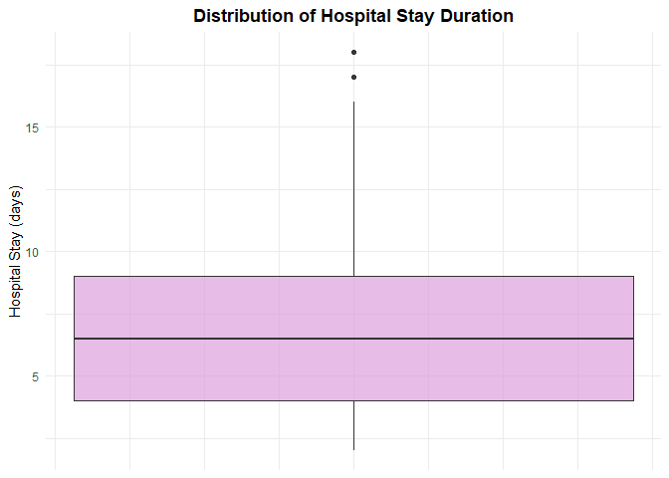

Section D: Association with Complications

Objective
Compare laboratory parameters between patients who developed complications vs. those who did not.
# Continuous laboratory parameters comparison
# Test: Wilcoxon rank-sum test (Mann-Whitney U) - non-parametric alternative to t-test
# Used due to potential non-normality in clinical lab data
cat("=== CONTINUOUS LABORATORY PARAMETERS vs COMPLICATIONS ===\n\n")
## === CONTINUOUS LABORATORY PARAMETERS vs COMPLICATIONS ===
# Total Leukocyte Count
test_tlc <- wilcox.test(tlc ~ any_complication, data = snake_df)
cat("Total Leukocyte Count:\n")
## Total Leukocyte Count:
cat(" Test: Wilcoxon rank-sum test\n")
## Test: Wilcoxon rank-sum test
cat(" p-value:", format.pval(test_tlc$p.value, digits = 3), "\n")
## p-value: 3.6e-08
cat(" Median (No complication):",
median(snake_df$tlc[snake_df$any_complication == "No"], na.rm = TRUE), "\n")
## Median (No complication): 10895
cat(" Median (Complication):",
median(snake_df$tlc[snake_df$any_complication == "Yes"], na.rm = TRUE), "\n")
## Median (Complication): 16194
if(test_tlc$p.value < 0.05) {
cat(" Interpretation: Significant difference detected (p < 0.05)\n\n")
} else {
cat(" Interpretation: No significant difference (p >= 0.05)\n\n")
}
## Interpretation: Significant difference detected (p < 0.05)
# Serum CRP
test_crp <- wilcox.test(crp ~ any_complication, data = snake_df)
cat("Serum CRP:\n")
## Serum CRP:
cat(" Test: Wilcoxon rank-sum test\n")
## Test: Wilcoxon rank-sum test
cat(" p-value:", format.pval(test_crp$p.value, digits = 3), "\n")
## p-value: 2.4e-09
cat(" Median (No complication):",
median(snake_df$crp[snake_df$any_complication == "No"], na.rm = TRUE), "\n")
## Median (No complication): 12.9
cat(" Median (Complication):",
median(snake_df$crp[snake_df$any_complication == "Yes"], na.rm = TRUE), "\n")
## Median (Complication): 34.8
if(test_crp$p.value < 0.05) {
cat(" Interpretation: Significant difference detected (p < 0.05)\n\n")
} else {
cat(" Interpretation: No significant difference (p >= 0.05)\n\n")
}
## Interpretation: Significant difference detected (p < 0.05)
# Serum LDH
test_ldh <- wilcox.test(ldh ~ any_complication, data = snake_df)
cat("Serum LDH:\n")
## Serum LDH:
cat(" Test: Wilcoxon rank-sum test\n")
## Test: Wilcoxon rank-sum test
cat(" p-value:", format.pval(test_ldh$p.value, digits = 3), "\n")
## p-value: 3.35e-10
cat(" Median (No complication):",
median(snake_df$ldh[snake_df$any_complication == "No"], na.rm = TRUE), "\n")
## Median (No complication): 272
cat(" Median (Complication):",
median(snake_df$ldh[snake_df$any_complication == "Yes"], na.rm = TRUE), "\n")
## Median (Complication): 577
if(test_ldh$p.value < 0.05) {
cat(" Interpretation: Significant difference detected (p < 0.05)\n\n")
} else {
cat(" Interpretation: No significant difference (p >= 0.05)\n\n")
}
## Interpretation: Significant difference detected (p < 0.05)
# Serum Albumin
test_albumin <- wilcox.test(albumin ~ any_complication, data = snake_df)
cat("Serum Albumin:\n")
## Serum Albumin:
cat(" Test: Wilcoxon rank-sum test\n")
## Test: Wilcoxon rank-sum test
cat(" p-value:", format.pval(test_albumin$p.value, digits = 3), "\n")
## p-value: 1.37e-08
cat(" Median (No complication):",
median(snake_df$albumin[snake_df$any_complication == "No"], na.rm = TRUE), "\n")
## Median (No complication): 3.8
cat(" Median (Complication):",
median(snake_df$albumin[snake_df$any_complication == "Yes"], na.rm = TRUE), "\n")
## Median (Complication): 3
if(test_albumin$p.value < 0.05) {
cat(" Interpretation: Significant difference detected (p < 0.05)\n\n")
} else {
cat(" Interpretation: No significant difference (p >= 0.05)\n\n")
}
## Interpretation: Significant difference detected (p < 0.05)
# Categorical laboratory abnormalities comparison
# Test: Chi-square test or Fisher's exact test (if expected frequencies < 5)
cat("=== CATEGORICAL LABORATORY ABNORMALITIES vs COMPLICATIONS ===\n\n")
## === CATEGORICAL LABORATORY ABNORMALITIES vs COMPLICATIONS ===
# Function to perform appropriate test
categorical_test <- function(var, var_name, outcome) {
contingency_table <- table(var, outcome)
# Check expected frequencies
chi_test <- chisq.test(contingency_table)
cat(var_name, ":\n")
print(contingency_table)
# Use Fisher's exact if any expected frequency < 5
if(any(chi_test$expected < 5)) {
fisher_test <- fisher.test(contingency_table)
cat(" Test: Fisher's exact test (due to small expected frequencies)\n")
cat(" p-value:", format.pval(fisher_test$p.value, digits = 3), "\n")
p_val <- fisher_test$p.value
} else {
cat(" Test: Chi-square test\n")
cat(" p-value:", format.pval(chi_test$p.value, digits = 3), "\n")
p_val <- chi_test$p.value
}
if(p_val < 0.05) {
cat(" Interpretation: Significant association detected (p < 0.05)\n\n")
} else {
cat(" Interpretation: No significant association (p >= 0.05)\n\n")
}
}
# Leukocytosis
categorical_test(snake_df$leukocytosis, "Leukocytosis", snake_df$any_complication)
## Leukocytosis :
## outcome
## var No Yes
## No 25 8
## Yes 24 43
## Test: Chi-square test
## p-value: 0.000394
## Interpretation: Significant association detected (p < 0.05)
# Elevated CRP
categorical_test(snake_df$elevated_crp, "Elevated CRP", snake_df$any_complication)
## Elevated CRP :
## outcome
## var No Yes
## No 16 1
## Yes 33 50
## Test: Chi-square test
## p-value: 0.000134
## Interpretation: Significant association detected (p < 0.05)
# Elevated LDH
categorical_test(snake_df$elevated_ldh, "Elevated LDH", snake_df$any_complication)
## Elevated LDH :
## outcome
## var No Yes
## No 20 2
## Yes 29 49
## Test: Chi-square test
## p-value: 2.54e-05
## Interpretation: Significant association detected (p < 0.05)
# Hypoalbuminemia
categorical_test(snake_df$hypoalbuminemia, "Hypoalbuminemia", snake_df$any_complication)
## Hypoalbuminemia :
## outcome
## var No Yes
## No 31 4
## Yes 18 47
## Test: Chi-square test
## p-value: 2.16e-08
## Interpretation: Significant association detected (p < 0.05)

Section E: Association with ICU Admission

Objective
Compare laboratory parameters between ICU-admitted and non-ICU patients.
# Continuous laboratory parameters comparison
cat("=== CONTINUOUS LABORATORY PARAMETERS vs ICU ADMISSION ===\n\n")
## === CONTINUOUS LABORATORY PARAMETERS vs ICU ADMISSION ===
# Total Leukocyte Count
test_tlc_icu <- wilcox.test(tlc ~ icu_admission, data = snake_df)
cat("Total Leukocyte Count:\n")
## Total Leukocyte Count:
cat(" Test: Wilcoxon rank-sum test\n")
## Test: Wilcoxon rank-sum test
cat(" p-value:", format.pval(test_tlc_icu$p.value, digits = 3), "\n")
## p-value: 8.49e-08
cat(" Median (No ICU):",
median(snake_df$tlc[snake_df$icu_admission == "No"], na.rm = TRUE), "\n")
## Median (No ICU): 10460.5
cat(" Median (ICU admitted):",
median(snake_df$tlc[snake_df$icu_admission == "Yes"], na.rm = TRUE), "\n")
## Median (ICU admitted): 16087.5
if(test_tlc_icu$p.value < 0.05) {
cat(" Interpretation: Significant difference detected (p < 0.05)\n\n")
} else {
cat(" Interpretation: No significant difference (p >= 0.05)\n\n")
}
## Interpretation: Significant difference detected (p < 0.05)
# Serum CRP
test_crp_icu <- wilcox.test(crp ~ icu_admission, data = snake_df)
cat("Serum CRP:\n")
## Serum CRP:
cat(" Test: Wilcoxon rank-sum test\n")
## Test: Wilcoxon rank-sum test
cat(" p-value:", format.pval(test_crp_icu$p.value, digits = 3), "\n")
## p-value: 2.03e-08
cat(" Median (No ICU):",
median(snake_df$crp[snake_df$icu_admission == "No"], na.rm = TRUE), "\n")
## Median (No ICU): 13.15
cat(" Median (ICU admitted):",
median(snake_df$crp[snake_df$icu_admission == "Yes"], na.rm = TRUE), "\n")
## Median (ICU admitted): 33.05
if(test_crp_icu$p.value < 0.05) {
cat(" Interpretation: Significant difference detected (p < 0.05)\n\n")
} else {
cat(" Interpretation: No significant difference (p >= 0.05)\n\n")
}
## Interpretation: Significant difference detected (p < 0.05)
# Serum LDH
test_ldh_icu <- wilcox.test(ldh ~ icu_admission, data = snake_df)
cat("Serum LDH:\n")
## Serum LDH:
cat(" Test: Wilcoxon rank-sum test\n")
## Test: Wilcoxon rank-sum test
cat(" p-value:", format.pval(test_ldh_icu$p.value, digits = 3), "\n")
## p-value: 3.68e-08
cat(" Median (No ICU):",
median(snake_df$ldh[snake_df$icu_admission == "No"], na.rm = TRUE), "\n")
## Median (No ICU): 277.5
cat(" Median (ICU admitted):",
median(snake_df$ldh[snake_df$icu_admission == "Yes"], na.rm = TRUE), "\n")
## Median (ICU admitted): 564.5
if(test_ldh_icu$p.value < 0.05) {
cat(" Interpretation: Significant difference detected (p < 0.05)\n\n")
} else {
cat(" Interpretation: No significant difference (p >= 0.05)\n\n")
}
## Interpretation: Significant difference detected (p < 0.05)
# Serum Albumin
test_albumin_icu <- wilcox.test(albumin ~ icu_admission, data = snake_df)
cat("Serum Albumin:\n")
## Serum Albumin:
cat(" Test: Wilcoxon rank-sum test\n")
## Test: Wilcoxon rank-sum test
cat(" p-value:", format.pval(test_albumin_icu$p.value, digits = 3), "\n")
## p-value: 4.06e-09
cat(" Median (No ICU):",
median(snake_df$albumin[snake_df$icu_admission == "No"], na.rm = TRUE), "\n")
## Median (No ICU): 3.8
cat(" Median (ICU admitted):",
median(snake_df$albumin[snake_df$icu_admission == "Yes"], na.rm = TRUE), "\n")
## Median (ICU admitted): 2.95
if(test_albumin_icu$p.value < 0.05) {
cat(" Interpretation: Significant difference detected (p < 0.05)\n\n")
} else {
cat(" Interpretation: No significant difference (p >= 0.05)\n\n")
}
## Interpretation: Significant difference detected (p < 0.05)
# Categorical laboratory abnormalities comparison
cat("=== CATEGORICAL LABORATORY ABNORMALITIES vs ICU ADMISSION ===\n\n")
## === CATEGORICAL LABORATORY ABNORMALITIES vs ICU ADMISSION ===
# Leukocytosis
categorical_test(snake_df$leukocytosis, "Leukocytosis", snake_df$icu_admission)
## Leukocytosis :
## outcome
## var No Yes
## No 29 4
## Yes 25 42
## Test: Chi-square test
## p-value: 5.18e-06
## Interpretation: Significant association detected (p < 0.05)
# Elevated CRP
categorical_test(snake_df$elevated_crp, "Elevated CRP", snake_df$icu_admission)
## Elevated CRP :
## outcome
## var No Yes
## No 17 0
## Yes 37 46
## Test: Chi-square test
## p-value: 9.23e-05
## Interpretation: Significant association detected (p < 0.05)
# Elevated LDH
categorical_test(snake_df$elevated_ldh, "Elevated LDH", snake_df$icu_admission)
## Elevated LDH :
## outcome
## var No Yes
## No 21 1
## Yes 33 45
## Test: Chi-square test
## p-value: 2.98e-05
## Interpretation: Significant association detected (p < 0.05)
# Hypoalbuminemia
categorical_test(snake_df$hypoalbuminemia, "Hypoalbuminemia", snake_df$icu_admission)
## Hypoalbuminemia :
## outcome
## var No Yes
## No 32 3
## Yes 22 43
## Test: Chi-square test
## p-value: 1.16e-07
## Interpretation: Significant association detected (p < 0.05)

Section F: Correlation Analysis

Objective
Perform Spearman’s rank correlation between laboratory parameters and hospital stay duration.
# Spearman's rank correlation
# Justification: Used for non-parametric correlation when data may not be normally
# distributed or when relationships may be monotonic but not necessarily linear
cat("=== SPEARMAN'S RANK CORRELATION WITH HOSPITAL STAY ===\n\n")
## === SPEARMAN'S RANK CORRELATION WITH HOSPITAL STAY ===
# Total Leukocyte Count
cor_tlc <- cor.test(snake_df$tlc, snake_df$hospital_stay,
method = "spearman", exact = FALSE)
cat("Total Leukocyte Count vs Hospital Stay:\n")
## Total Leukocyte Count vs Hospital Stay:
cat(" Spearman's rho:", round(cor_tlc$estimate, 3), "\n")
## Spearman's rho: 0.728
cat(" p-value:", format.pval(cor_tlc$p.value, digits = 3), "\n")
## p-value: <2e-16
if(cor_tlc$p.value < 0.05) {
direction <- ifelse(cor_tlc$estimate > 0, "positive", "negative")
cat(" Interpretation: Significant", direction, "correlation (p < 0.05)\n\n")
} else {
cat(" Interpretation: No significant correlation (p >= 0.05)\n\n")
}
## Interpretation: Significant positive correlation (p < 0.05)
# Serum CRP
cor_crp <- cor.test(snake_df$crp, snake_df$hospital_stay,
method = "spearman", exact = FALSE)
cat("Serum CRP vs Hospital Stay:\n")
## Serum CRP vs Hospital Stay:
cat(" Spearman's rho:", round(cor_crp$estimate, 3), "\n")
## Spearman's rho: 0.857
cat(" p-value:", format.pval(cor_crp$p.value, digits = 3), "\n")
## p-value: <2e-16
if(cor_crp$p.value < 0.05) {
direction <- ifelse(cor_crp$estimate > 0, "positive", "negative")
cat(" Interpretation: Significant", direction, "correlation (p < 0.05)\n\n")
} else {
cat(" Interpretation: No significant correlation (p >= 0.05)\n\n")
}
## Interpretation: Significant positive correlation (p < 0.05)
# Serum LDH
cor_ldh <- cor.test(snake_df$ldh, snake_df$hospital_stay,
method = "spearman", exact = FALSE)
cat("Serum LDH vs Hospital Stay:\n")
## Serum LDH vs Hospital Stay:
cat(" Spearman's rho:", round(cor_ldh$estimate, 3), "\n")
## Spearman's rho: 0.851
cat(" p-value:", format.pval(cor_ldh$p.value, digits = 3), "\n")
## p-value: <2e-16
if(cor_ldh$p.value < 0.05) {
direction <- ifelse(cor_ldh$estimate > 0, "positive", "negative")
cat(" Interpretation: Significant", direction, "correlation (p < 0.05)\n\n")
} else {
cat(" Interpretation: No significant correlation (p >= 0.05)\n\n")
}
## Interpretation: Significant positive correlation (p < 0.05)
# Serum Albumin
cor_albumin <- cor.test(snake_df$albumin, snake_df$hospital_stay,
method = "spearman", exact = FALSE)
cat("Serum Albumin vs Hospital Stay:\n")
## Serum Albumin vs Hospital Stay:
cat(" Spearman's rho:", round(cor_albumin$estimate, 3), "\n")
## Spearman's rho: -0.867
cat(" p-value:", format.pval(cor_albumin$p.value, digits = 3), "\n")
## p-value: <2e-16
if(cor_albumin$p.value < 0.05) {
direction <- ifelse(cor_albumin$estimate > 0, "positive", "negative")
cat(" Interpretation: Significant", direction, "correlation (p < 0.05)\n\n")
} else {
cat(" Interpretation: No significant correlation (p >= 0.05)\n\n")
}
## Interpretation: Significant negative correlation (p < 0.05)
Justification for Spearman’s Correlation:
Spearman’s rank correlation is appropriate for this analysis because:
- Clinical laboratory data often exhibit non-normal distributions with outliers
- The relationship between biomarkers and hospital stay may be monotonic but not strictly linear
- Spearman’s method is robust to extreme values common in clinical datasets
- It does not assume normality or homoscedasticity
# Scatter plot visualization (example: CRP vs Hospital Stay)
ggplot(snake_df, aes(x = crp, y = hospital_stay)) +
geom_point(alpha = 0.6, color = "steelblue", size = 2.5) +
geom_smooth(method = "lm", se = TRUE, color = "red", linetype = "dashed") +
labs(
title = "Correlation between Serum CRP and Hospital Stay Duration",
subtitle = paste("Spearman's rho =", round(cor_crp$estimate, 3),
", p-value =", format.pval(cor_crp$p.value, digits = 3)),
x = "Serum CRP (mg/L)",
y = "Hospital Stay (days)"
) +
theme_minimal() +
theme(
plot.title = element_text(hjust = 0.5, face = "bold"),
plot.subtitle = element_text(hjust = 0.5)
)
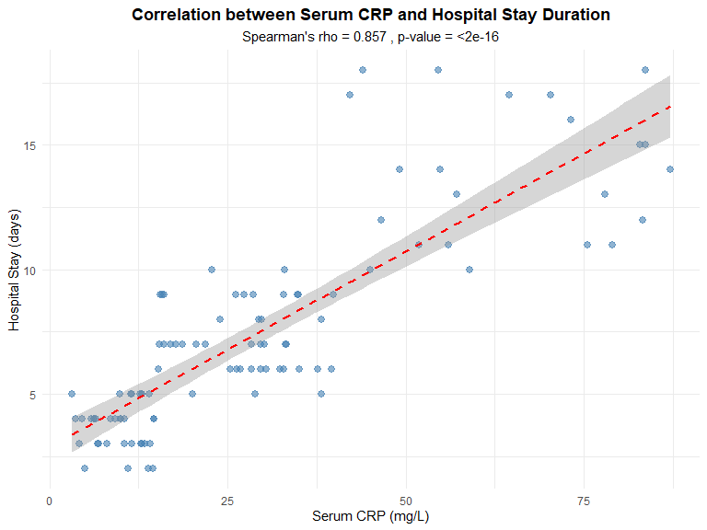

Section G: Interpretation and Professional Judgement

Why is correlation analysis appropriate in this context?
Correlation analysis is appropriate for this observational clinical dataset because it allows us to:
- Quantify relationships: Measure the strength and direction of association between laboratory biomarkers and clinical outcomes like hospital stay duration without making assumptions about causality.
- Identify potential prognostic markers: Determine which laboratory parameters show meaningful associations with patient outcomes, informing hypothesis generation for future research.
- Guide clinical decision-making: Correlations can suggest which biomarkers might be useful for risk stratification or monitoring disease severity, though they require validation through prospective studies.
- Data exploration: In an observational study, correlation analysis serves as an exploratory tool to understand patterns in the data before conducting more complex analyses.

Why should regression modelling be used?
Regression modelling should be used because it provides several advantages over simple correlation:
- Multivariable adjustment: Regression allows simultaneous evaluation of multiple predictors while controlling for potential confounders such as age, comorbidities, and severity of envenomation.
- Effect quantification: Unlike correlation which only measures association strength, regression provides interpretable coefficients that estimate the magnitude of change in the outcome for a unit change in the predictor.
- Model building: Enables identification of independent predictors of outcomes by assessing each variable’s contribution while holding others constant.
- Prediction: Regression models can be used to develop risk prediction tools for clinical use, such as predicting ICU admission likelihood or complication risk based on admission parameters.
- Handling non-linearity and interactions: Advanced regression techniques can model complex relationships and interaction effects between variables that simple correlation cannot capture.

Why should causality not be inferred?
Causality should not be inferred from this observational study for several critical reasons:
- Study design limitations: This is an observational cross-sectional or retrospective cohort study, not a randomized controlled trial. Without randomization, we cannot eliminate confounding by unmeasured variables.
- Temporal ambiguity: While some measurements are taken at admission, the temporal sequence between certain exposures and outcomes may be unclear, making it difficult to establish that the exposure preceded the outcome.
- Confounding: Multiple unmeasured or uncontrolled factors (e.g., snake species, venom load, time to treatment, pre-hospital care, genetic factors) could influence both laboratory parameters and clinical outcomes, creating spurious associations.
- Reverse causation: In some cases, the outcome itself might influence the biomarker levels rather than vice versa (e.g., complications leading to inflammatory marker elevation).
- Bradford Hill criteria: Establishing causation requires fulfilling multiple criteria including temporal relationship, dose-response, biological plausibility, consistency across studies, and experimental evidence—none of which can be fully assessed from a single observational dataset.
- Association ≠ causation: Statistical significance and correlation indicate association only. Even strong associations may reflect shared underlying mechanisms rather than direct causal pathways.
Professional responsibility: As data analysts and researchers, we must clearly communicate that our findings suggest associations that warrant further investigation through prospective, interventional, or mechanistic studies, rather than establishing causal relationships.

Section H: Code Quality and Reproducibility

Session Information
```{r} # Document R session for reproducibility
sessionInfo()
## R version 4.5.2 (2025-10-31 ucrt)
## Platform: x86_64-w64-mingw32/x64
## Running under: Windows 11 x64 (build 26200)
##
## Matrix products: default
## LAPACK version 3.12.1
##
## locale:
## [1] LC_COLLATE=English_India.utf8 LC_CTYPE=English_India.utf8
## [3] LC_MONETARY=English_India.utf8 LC_NUMERIC=C
## [5] LC_TIME=English_India.utf8
##
## time zone: Asia/Calcutta
## tzcode source: internal
##
## attached base packages:
## [1] stats graphics grDevices datasets utils methods base
##
## other attached packages:
## [1] gridExtra_2.3 knitr_1.51 psych_2.5.6 lubridate_1.9.4
## [5] forcats_1.0.1 stringr_1.6.0 dplyr_1.1.4 purrr_1.2.1
## [9] readr_2.1.6 tidyr_1.3.2 tibble_3.3.1 ggplot2_4.0.1
## [13] tidyverse_2.0.0
##
## loaded via a namespace (and not attached):
## [1] generics_0.1.4 renv_1.1.6 stringi_1.8.7 lattice_0.22-7
## [5] hms_1.1.4 digest_0.6.39 magrittr_2.0.4 evaluate_1.0.5
## [9] grid_4.5.2 timechange_0.3.0 RColorBrewer_1.1-3 fastmap_1.2.0
## [13] Matrix_1.7-4 mgcv_1.9-3 scales_1.4.0 mnormt_2.1.1
## [17] cli_3.6.5 rlang_1.1.7 crayon_1.5.3 splines_4.5.2
## [21] bit64_4.6.0-1 withr_3.0.2 yaml_2.3.12 tools_4.5.2
## [25] parallel_4.5.2 tzdb_0.5.0 vctrs_0.7.0 R6_2.6.1
## [29] lifecycle_1.0.5 bit_4.6.0 vroom_1.6.7 pkgconfig_2.0.3
## [33] pillar_1.11.1 gtable_0.3.6 glue_1.8.0 xfun_0.56
## [37] tidyselect_1.2.1 rstudioapi_0.18.0 farver_2.1.2 htmltools_0.5.9
## [41] nlme_3.1-168 rmarkdown_2.30 labeling_0.4.3 compiler_4.5.2
## [45] S7_0.2.1

